Case Study
on
openSUSE Leap 16
Submitted
In the partial fulfilment of the requirements for
completion of
Bachelor of Technology IV Semester
in
Computer Science Engineering
by
Timothy Saxena (24261A05R4)
V Harshini (24261A05R5)
Vanam Sai Mani Akshat (24261A05R6)

Under the guidance of
Mrs. VEDAVATHI. K
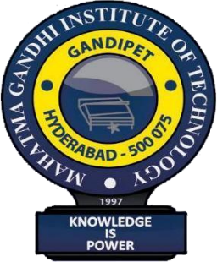
(Assistant Professor)

DEPARTMENT OF COMPUTER SCIENCE AND ENGINEERING MAHATMA GANDHI INSTITUTE OF TECHNOLOGY GANDIPET, HYDERABAD-500 075, INDIA
2025-2026


MAHATMA GANDHI INSTITUTE OF TECHNOLOGY
(Affiliated to Jawaharlal Nehru Technological University Hyderabad)
Gandipet, Hyderabad-500 075, Telangana
(India)


CERTIFICATE

This is to certify that the case study entitled “Case Study on openSUSE Leap 16”, is being submitted by Timothy Saxena, V Harshini, Vanam Sai Mani Akshat bearing 24261A05R4, 24261A05R5, 24261A05R6 in partial fulfilment for competition of Bachelor of Technology IV Semester in Computer Science and Engineering to Mahatma Gandhi Institute of Technology is a record of bona-fide work carried out by us under our guidance and supervision. The results embodied in this case study has not been submitted to any other University or Institute for the award of any degree or diploma.

Faculty Name Head of the Department
Mrs. K. Vedavathi Dr. C.R.K. Reddy
Asst. Professor, Dept of CSE Professor, Dept. of CSE

DECLARATION

This is to certify that the work reported in Operating Systems Laboratory titled “Case Study on openSUSE Leap 16” is a record of work done by us in the Department of Computer Science and Engineering, Mahatma Gandhi Institute of Technology, Hyderabad. No part of the work is copied from books/journals/internet and wherever the portion is taken, the same has been duly referred to in the text. The report is based on the work done entirely by us and not copied from any other source.

Timothy Saxena (24261A05R4)
V Harshini (24261A05R5)
Vanam Sai Mani Akshat (24261A05R6)

Table of Contents

- Introduction 3
- Overview 4
- History and Evolution 6
- Design 8
- User Interface and Experience 10
- Kernel Architecture 13
- Components of openSUSE Leap 16 Operating System:
  - Process Management 17
  - Main Memory Management 20
  - File System Management 24
  - Secondary Storage Management 27
  - Device Management 31
  - I/O System Management 36
  - Protection and Security 40
- IPC 44
- Networking 48
- Conclusion 52
- References 54

